**BTEC - Engineering**

**Unit 2 – Learning Aim C**

**Understand the selection and use of manufacturing processes in an engineered product**

**Introduction**

The engineered product that I have been studying was the keyboard and in this essay I shall be focusing on the manufacturing processes involve excursion and infection moulding.

Components

The components I will be looking at (shown below) are both made of a form of plastic. The components are; the PTFE casing around the wire of the USB and the ABS case of the keyboard.

The Casing around the wires of the USB is a very simple part of the keyboard as it is used for insulating the wires but is mostly used to make it so we only need one wire instead of having the wires inside trailing around but is still used as a secondary source of insulation.

The casing around the keyboard is made of ABS meaning that is will be quite

Ribs that require a degree of accuracy

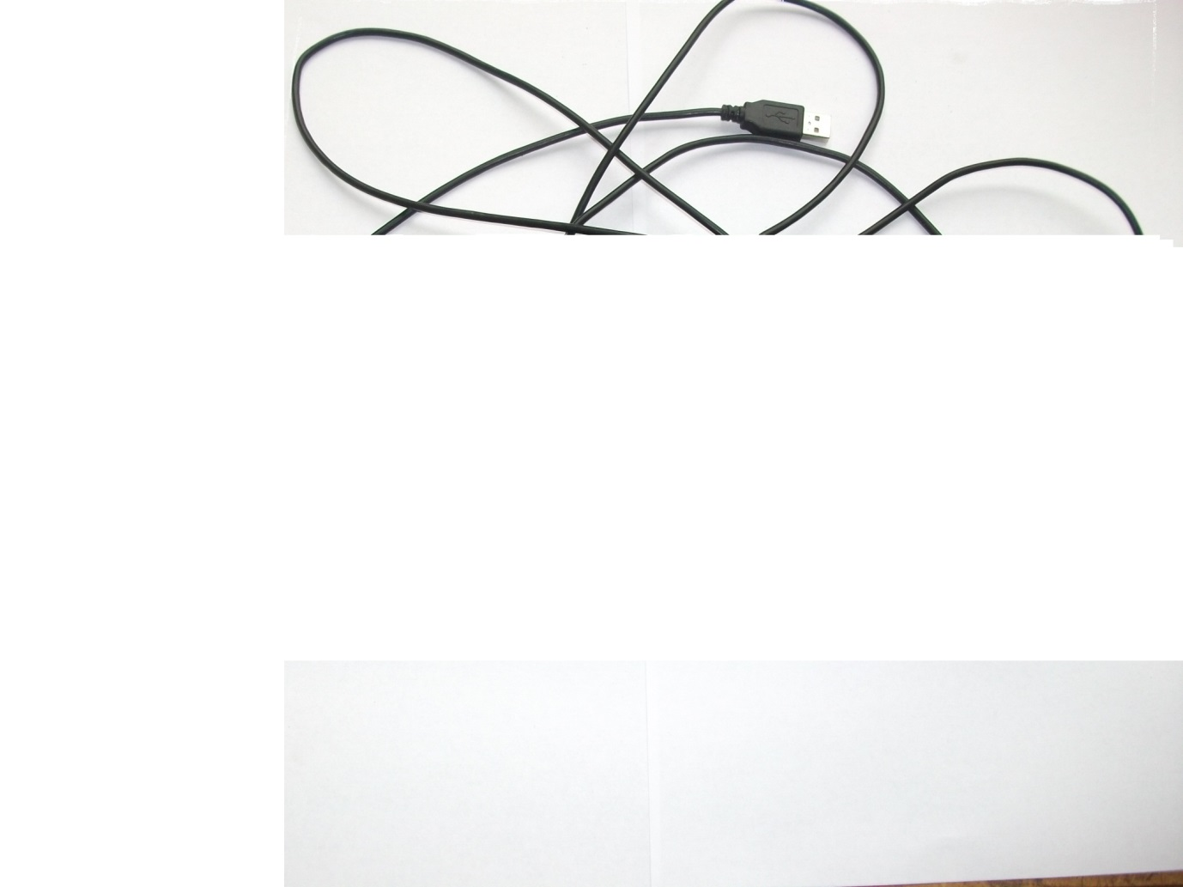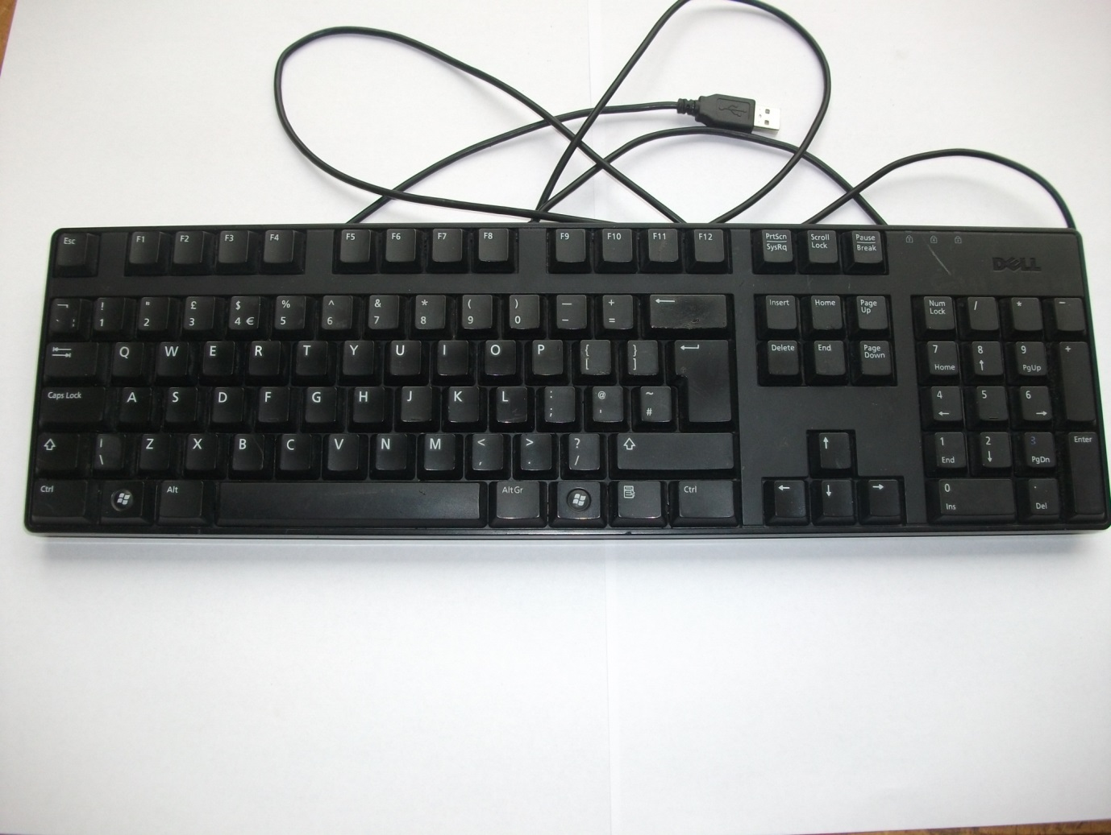

Abs casing (the component I will be studying)

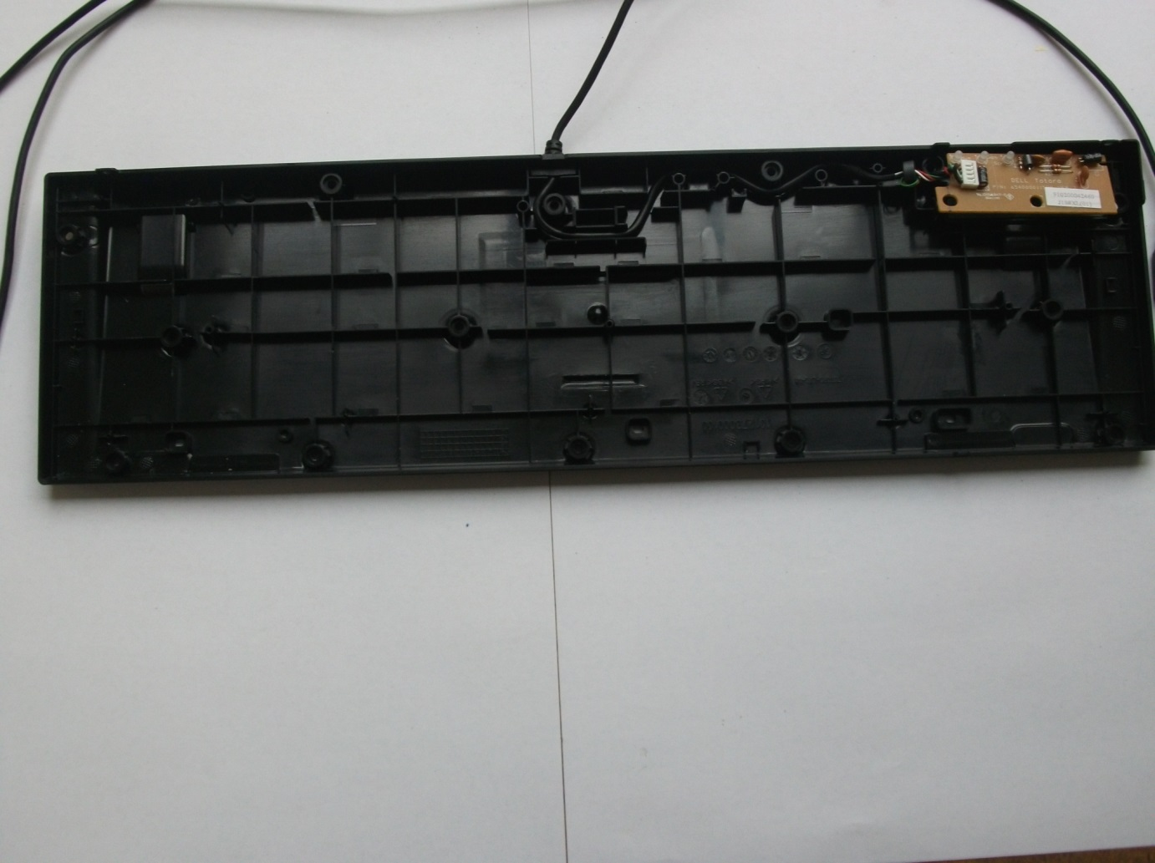

The wire Polytetrafluoroeth-ylene (PTFE) casing

Manufacturing Processes

|  |  |  |
| --- | --- | --- |
| The Part | Process | Reasons for use |
| The wire casing that connects between the keyboard and USB. | Excursion | Its I required to be a hollow so that it may fit the wires inside and also need to be a very long cable so excursion. |
| The keyboard case | Injection moulding | It is used because they keyboard case is require to be very precise so that all the keys will be in the right place and also it is process that can be performed relatively quickly because the dies can be reused. |

Environmental Impact

The environmental impact of injection moulding comes from the disposal of the waste material. This is because if the materials are not recycled then they will be placed in a landfill and slowly left to degrade. The problem with this is that they are plastics so they will not be able to degrade so they will remain in the ground almost for ever. The other possible environmental issue is that it is a process that requires electricity which can be generated in a verity of ways and these ways

Advantages and disadvantages

*Investigate advantages and disadvantages of each process used*

|  |  |  |
| --- | --- | --- |
| *Process* | *Advantages* | *Disadvantages* |
|  |  |  |
|  |  |  |